**NAME**…………………………………………………………......................................................PERSONAL NUMBER……………………………………………….

STREAM………………………………………………………………

**RAISE THE ROOF HIGH SCHOOL**

UGANDA CERTIFICATE OF LOWER SECONDARY EDUCATION

**END OF TERM 1 S.3 PHYSICAL EDUCATION EXAM 2023**

TIME; 2HRS

**INSTRUCTIONS TO CANDIDATE**

This paper consists of two sections A and B

Answer all questions

Answer for section A should be written in the space provided

Answers for section B should be written in the answer booklet provided

Un necessary crossing of work can lead to loss of marks. Be smart

**FOR EXAMINERS USE ONLY**

|  |  |
| --- | --- |
| SECTION |  |
| A |  |
| B |  |
| TOTAL |  |

**SECTION A. (50 MARKS)**

1. In sports, it is advisable to eat different nutrients in order to maintain a healthy body and also acquire energy to perform physical activities. Give the meaning of ;
2. Nutrition. …………………………………………………………………………………………………………………………………………………………………………….
3. Balanced diet. ………………………………………………………………………………………………………………………………………………………………………………
4. Over eating. ………………………………………………………………………………………………………………………………………………………………………………
5. Under eating. ……………………………………………………………………………………………………………………………………………………………………………...

(1 mark @)

1. Why do sports people need special diets? …………………………………………………………………………………………………………………………………………………………………………………………………………………………………………………………………………………………………………………………………………………………………………………………………………………………………………………………………............. (4 marks)
2. Below are pictures showing different meals. Study them carefully and answer the questions that follow.

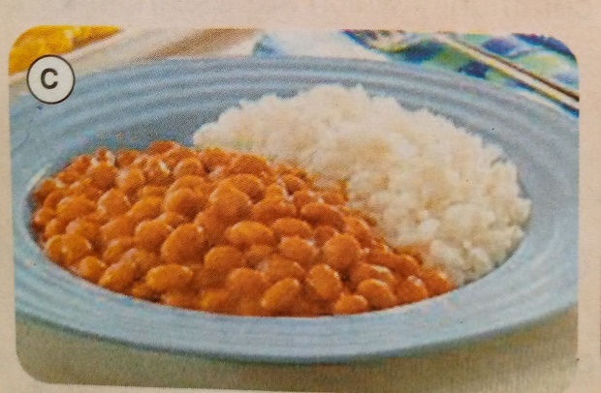 

1. State the nutrients provided by the meals in the pictures A and B. (2 marks)
2. ……………………………………………………………………………………………………………………………………………………………..
3. …………………………………………………………………………………………………………………………………………………………….
4. Which meal is healthy for a sports person? Give a reason for your answer. …………………………………………………………………………………………………………………………………………………………………(2 marks)
5. Suggest disadvantages of under eating and over to a sports person.

Under eating. ……………………………………………………………………………………………………………………………………………………………………………………………………………………………………………………………………………………………………………………………………………………………………………………………………………………………… …………………………………………………………………………………………………………………………………………………………………………………………………………………………………………………………………………………………………………………………………………….. (4 marks)

Over eating. …………………………………………………………………………………………………………………………………………………………………………………………………………………………………………………………………………………………………………………………………………………………………………………………………………………………………………………………………………………………………………………………………………………………………………………………………………………………………………………………………………………………………………………………………………………………………………………………………………………………………………... (4 marks)

1. Study the pictures below carefully and answer the questions that follow

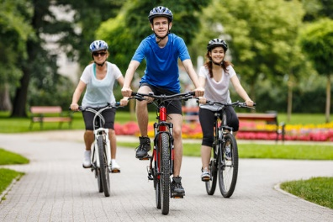 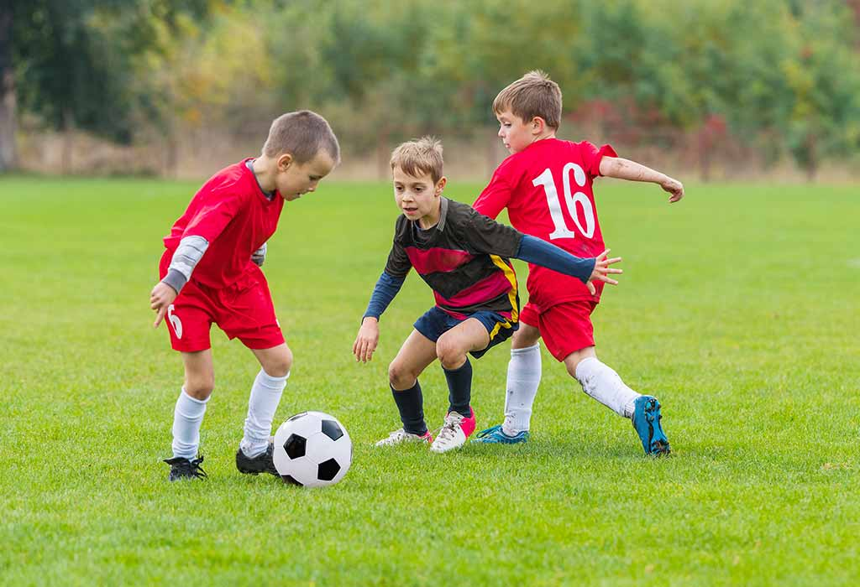 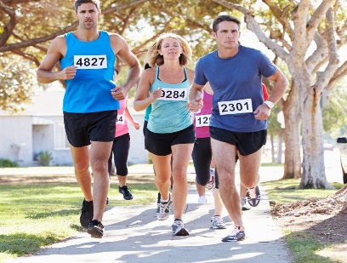 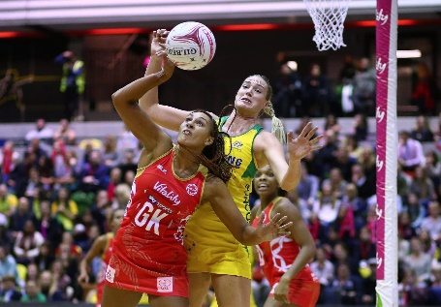

1. Explain what is happening in each of the pictures above.
2. ……………………………………………………………………………………………………………………………………………………………………………(1 mark)
3. ……………………………………………………………………………………………………………………………………………………………………………(1 mark)
4. …………………………………………………………………………………………………………………………………………………………………………..(1 mark)
5. ……………………………………………………………………………………………………………………………………………………………………………(1 mark)
6. Identify the pictures which represent activities involving the use of;
7. Much physical strength. ………………………………………………………………………………………
8. Less physical strength. ………………………………………………………………………………………
9. Less mental strength. ………………………………………………………………………………………
10. More mental strength. ……………………………………………………………… ( a half mark @)
11. What general name is given to people participating in activity
12. ……………………………………………………………………………(1 mark)
13. ……………………………………………………………………………(1 mark)
14. During inter house competitions at Raise the Roof high school, netball was one of the sports activities which was performed however many accidents occurred. As a student of physical education, states any **5** safety precautions that could been done to reduce the occurrence of accidents during athletics. (5 marks). ………………………………………………………………………………………………………………………………………………………………………………………………………………………………………………………………………………………………………………………………………………………………………………………………………………………………………………………………………………………………………………………………………………………………………………………………
15. Outline any 6 skills executed when playing netball. (3 marks) ………………………………………………………………………………………………………………………………………………………………………………………………………………………………………………………………………………………………
16. Name the different positions in netball team and state the roles played by each in the netball team. (7 marks) ……………………………………………………………………………………………………………………………………………………………………………………………………………………………………………………………………………………………………………………………………………………………………………………………………………………………………………………………………………………………………………………………………………………………………………………………………………………………………………………………………………………………..
17. Athletics are categorized into field athletic events and track athletic events. Mention 4;
18. Track athletic events. (2marks) ………………………………………………………………………………………………………………………………………………………………………………………………………………………………………………………………………………………………………………………………………………………………
19. Field athletic events. (2 marks) ………………………………………………………………………………………………………………………………………………………………………………………………………………………………………………………………………………………………………………………………………………………………
20. State the ways of stating a race. (1 mark)
21. ………………………………………………………………………………………
22. ………………………………………………………………………………………
23. Write down the procedures of performing the way of starting a race indicated in picture A (6marks)

On your marks. ………………………………………………………………………………………………………………………………………………………………………………………………………………………………………………………………………………………………………………………………………………………………………………………………………………………………

Get set. ……………………………………………………………………………………………………………………………………………………………………………………………………………………………………………………………………………………………………………………………………………………………………………………………………………………………....

Go. ……………………………………………………………………………………………………………………………………………………………………………………………………………………………………………………………………………………………………………………………………………………………………………………………………………………………………………………………………………………………………………………………………..

**SECTION B. (50 MARKS)**

1. Netball is one of the amazing games and your school is to host netball games competition and you have been selected to demarcate the netball court. Draw a sketch of a netball court including all the measurements and different positions of the players. (10 marks)
2. First aid is one of the major components and important practice in physical education because it helps to save life. Give the meaning of;
3. Accident
4. Safety
5. First aid box
6. Casualty
7. First aider (1 mark @)

b). State **five** qualities of a good first aider. (5 marks)

c).Discuss the DRABC routine of giving first aid (10 marks)

8. Volley ball is a game played by 12 players in a volley ball court. Mention at least six skills executed in a volley ball game (3 marks)

b) Mention the rules followed when playing a volley ball game. (7 marks)

9. all sports and games require specific skills to execute them. What is the meaning of a skill? (1 marks)

Giving examples state two types of skills (4 marks)

Explain any five factors that affect skill performance and development. (5 marks)*END* GOOD LUCK! #GOOD HEALTH COMES FROM PERFORMING PHYSICAL ACTIVITIES#